Movie Storyline
1. Match the posters with the storylines. Check your answers with the class.
1 | 2 | 3
 | 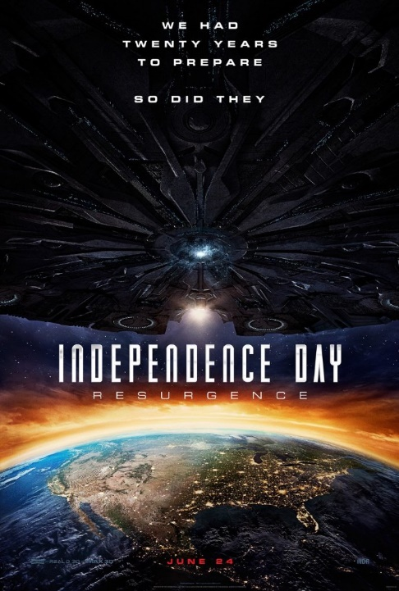 | 
4 | 5 | 6
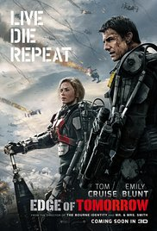 | 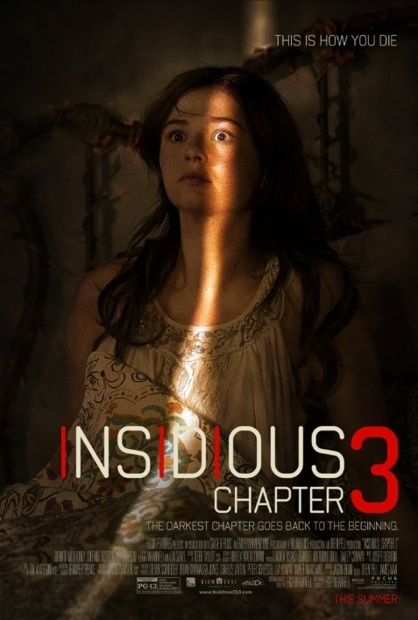 | 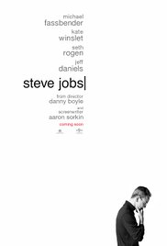

Storyline A
The adventures of writer Newt Scamander who is very celebrated in New York's secret community of witches and wizards seventy years before Harry Potter reads his book in school. (adapted from www.imdb.com)

Storyline B
Two decades after the freak alien invasion that nearly destroyed mankind, a new threat emerges. This Alien mothership is more than twice the size as the last one and once again, the world's armies must band together to save the world which is once again in peril. Do they have enough firepower or will this battle change and will aliens take over? (adapted from www.imdb.com)

Storyline C
His passion and ingenuity which have inspired hundreds of million people have been the driving force behind the digital age. However, his drive to revolutionize technology was sacrificial. Ultimately it affected his family life and possibly his health. In this revealing film we explore the trials and triumphs of a modern day genius, the late CEO of Apple inc. (adapted from www.imdb.com)

Storyline D
The peaceful realm of Azeroth which holds beautiful land and scenery stands on the brink of war as its civilization faces a fearsome race of invaders: orc warriors fleeing their dying home to colonize another. As a portal opens to connect the two worlds, one army faces destruction and the other faces extinction. From opposing sides, two heroes are set on a collision course that will decide the fate of their family, their people, and their home. (adapted from http://www.imdb.com/title/tt0803096/?ref_=fn_al_tt_1)

Storyline E
After trying to connect with her mother who has passed away, teenager Quinn Brenner, asks psychic Elise Rainier to help her. She refuses due to negotiate events in her childhood. Quinn starts noticing paranormal events happen in her house. After a vicious attack from a demon which is as frightening as ever. Her father goes back and begs Elise Rainier to use her abilities to contact the other side in hope to stop these attacks by this furious demon content for a body. (adapted from http://www.imdb.com/title/tt3195644/?ref_=nv_sr_3)

Storyline F
An alien race has hit the Earth in an unrelenting assault which is unbeatable by any military unit in the world. Major William Cage (Cruise) is an officer who has never seen a day of combat when he is unceremoniously dropped into what amounts to a suicide mission. Killed within minutes, Cage now finds himself inexplicably thrown into a time loop-forcing him to live out the same brutal combat over and over, fighting and dying again...and again. But with each battle, Cage becomes able to engage the adversaries with increasing skill, alongside Special Forces warrior Rita Vrataski (Blunt). And, as Cage and Vrataski take the fight to the aliens, each repeated encounter gets them one step closer to defeating the enemy that is really powerful! (adapted from http://www.imdb.com/title/tt1631867/?ref_=nv_sr_1)

2. Read the storyline again. You may check the online articles for further information. Categorize the
movies based on the types of relationship.

Relationships | Title of the Movie | Your Reason | Other Similar Movies
Friendship
Family Relationship
Romantic Relationship
Professional Relationship

Grammar and Vocabulary Explorations

3. Find out the part of speech, pronunciation, and definition of these following words. Then, make
sentences. An example has been provided for you.

No. | Word | Definition
1. | band | surround (an object) with something in the form of a strip or ring, typically for reinforcement or decoration.
Sentence: The world's armies must band together to save the world.

2.
3.
4.
5.
6.
7.
8.
9.
10.
11.
12.
13.

